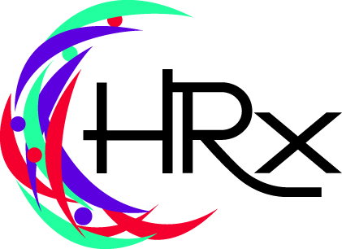
Keynotes, Training and Seminars
Arlene Vernon

The following is a consolidated list of sample programs that can be conducted as Keynotes, Training or Breakout Sessions or Seminars.
Each can be conducted individually, merged into an integrated session or presented as a series of on-going training for your leaders. We are pleased to customize these and other programs for your organization.
Control-Click on any of the programs to link to a program description.

SAMPLE PROGRAMS

- Ask the HRxpert
- Attracting and Retaining the Best
- Bullying in the Workplace
- Communication Skills
- Conducting Performance Appraisals
- Conflict Management
- Creating Corporate Culture
- Dealing with Difficult Employees
- Developing Employee Handbooks
- Discipline, Documentation and Dismissal
- Employee Engagement
- From Buddy to Boss
- General Supervisory Skills
- Giving Performance Feedback
- Harassment Training
- Hiring the Best Without A Crystal Ball
- Intuition and Decision Making
- Leading Like a Star
- Leadership: An Inside-Out Approach
- Managing Change
- Managing from the Middle
- Managing the Employee Life Cycle
- Onboarding: Orientation and Training
- Presentation Skills
- Recognition, Reward and Retention
- Respect in the Workplace
- Team Building
- The A to Z of HR for Smaller Organizations
- Time Management
- Writing Job Descriptions

MUSICAL KEYNOTES
- Find Your Voice – Sing Out Loud
- Personnel Parodies: A Day in the Life of an HR Pro
- Melodies to Motivate Managers

